|  |  |  |  |  |  |  |  |  |  |  |  |  |  |  |  |  |  |
| --- | --- | --- | --- | --- | --- | --- | --- | --- | --- | --- | --- | --- | --- | --- | --- | --- | --- |
| 附件1：报名表（可编辑的电子版）  **考生报名登记表**  **报考岗位及代码：XXXX** | | | | | | | | | | | | | | | | | |
| **姓名** | | XX | | **性别** | X | **民族** | X | **出生日期** | XXXX | | **籍贯** | | | | XX | **C:\Users\Administrator\AppData\Local\Temp\WeChat Files\7355dd9e2035a69d638473b9cdea95e.jpg** | |
| **户籍** | | XXX | | **住地** | **XXX** | | | **婚姻状况** | XX | | **政治面貌** | | | | XX |
| **身份证号** | | | | | **XXXXXXXX** | | | **联系电话** | **XXXXXXXXXXXXX** | | | | | | |
| **最高学历** | | | | | **XXXXXX** | | | **专业** | XXXXXX | | **职称** | | | | X |
| **毕业院校** | | | | | XXXXXX | | | **毕业日期** | XXXXX | **紧急联系人联系方式** | | | XXXXXX | | |
| **主要学习简历** | **起止年月** | | | | **就读院校** | | | | | | | **所学专业** | | | | **证书名称** | |
| XXXXXX | | | | XX学校（从高中为起点） | | | | | | | XXX | | | | XXXX | |
| XXXXX | | | | XXXXXX | | | | | | | XXXX | | | | XXXX | |
|  | | | |  | | | | | | |  | | | |  | |
| **工作经历** | **起止年月** | | | | **工作单位** | | | | | | | **部门/职位** | | | | | |
| XXXX | | | | XXXXX从最近工作开始写 | | | | | | | XXX | | | | | |
| XXXX | | | | XXXXX | | | | | | | XXX | | | | | |
|  | | | |  | | | | | | |  | | | | | |
| **家庭主要成员及社会关系** | **姓名** | | **与本人关系** | | **工作单位** | | | | | | | **部门/职位** | | | | | |
| XX | | 父亲 | | XXXX | | | | | | | XXX | | | | | |
| XX | | 母亲 | | XXXX | | | | | | | XXX | | | | | |
| XX | | 配偶 | | XXXX | | | | | | | XXX | | | | | |
| **职称及从业资格等** | | | **XXXX** | | | | | | | | | | | | | | |
| **个人简介** | | | **XXXXX** | | | | | | | | | | | | | | |
|
| **通信地址** | | | 填写现居住地址 | | | | | | **邮编** | XXX | | | | **电子邮箱** | | | XXXX |
| **本人承诺** | **本人承诺以上填写内容全部真实有效**  **承诺人（签名）：请手写签名**  **年 月 日** | | | | | | | | | | | | | | | | |

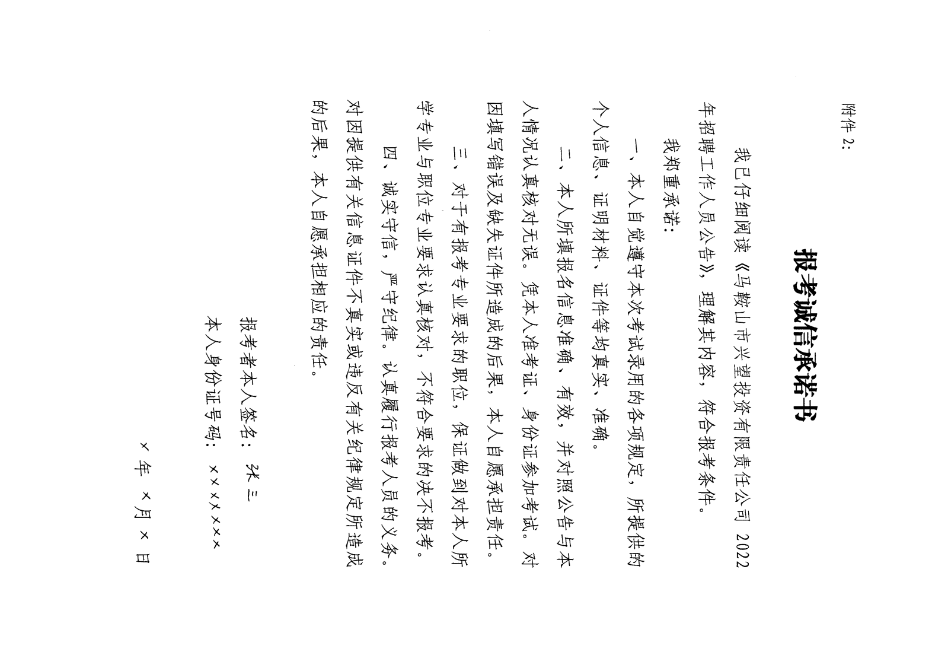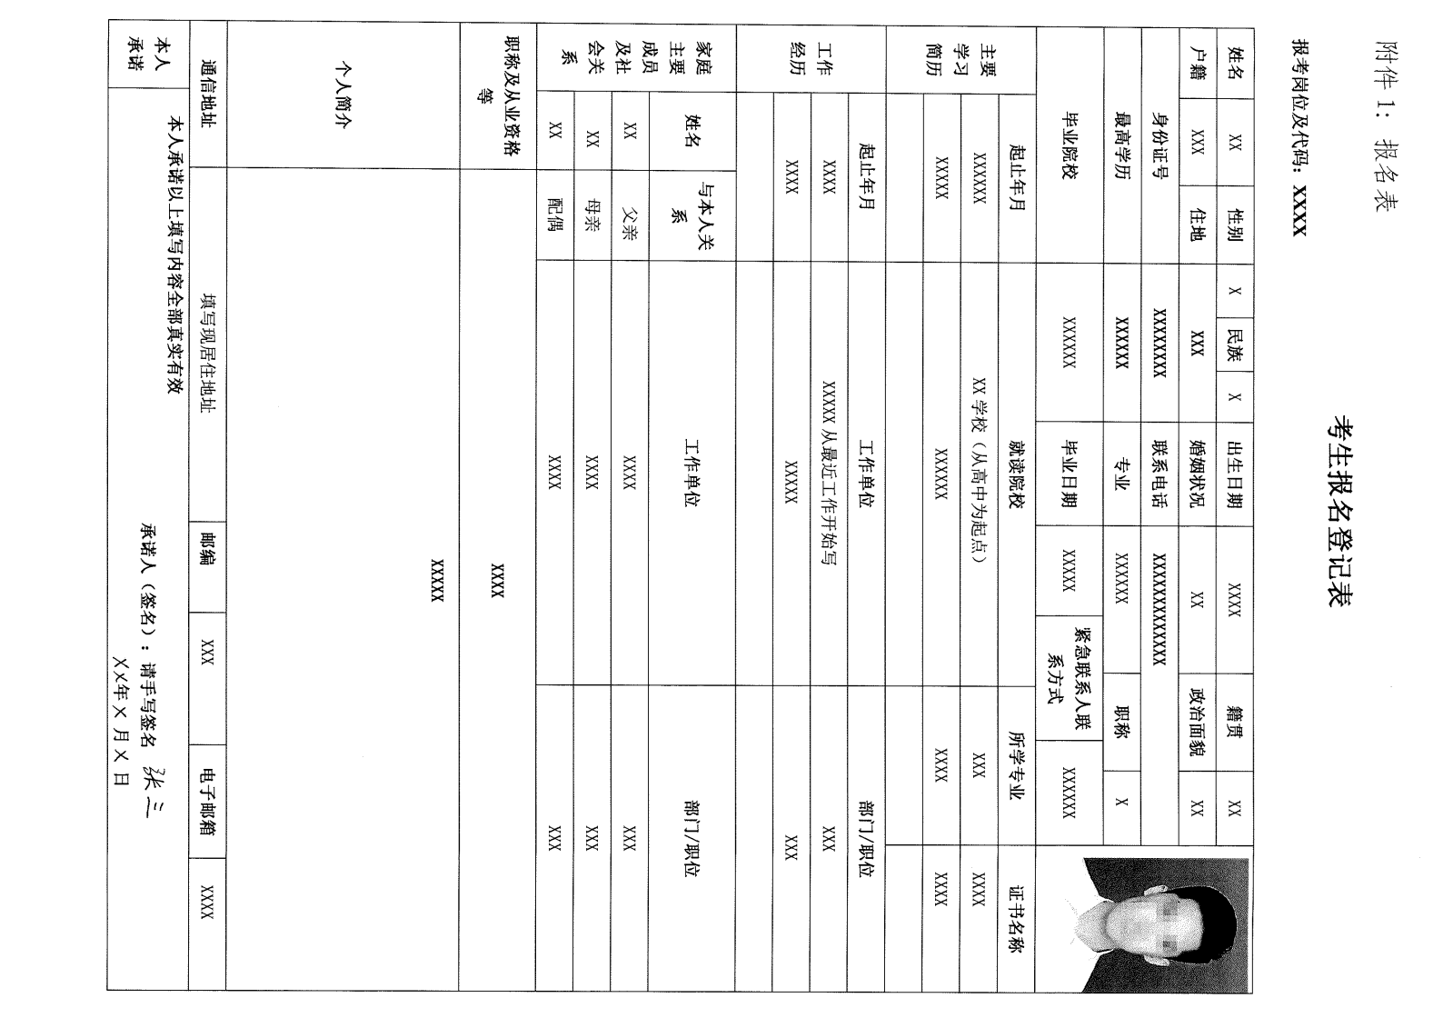

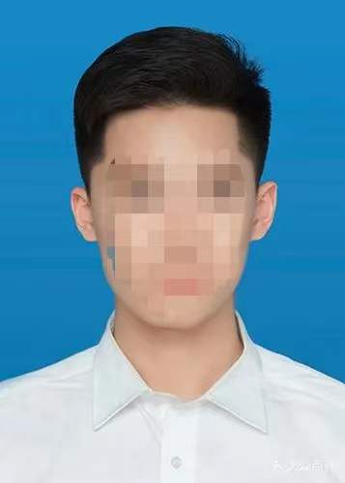**四、身份证（正反面）**

**五、学历证书**

**六、学位证书**

**七、学历以及学位证书影印件和教育部学籍在线验证报告（学信网）**

**八、社保流水**

**九、其他相关证书影印版**